MACH4METAL

metalworking machinery
Transito 21
6909 DA BABBERICH Netherlands
Tel. +31 (0)316-247123
Fax: +31 (0)316-247956
info@mach4metal.com
www.mach4metal.com

Bank No : 66.52.13.883
IBAN : NL33 INGB 0665 2138 83
BIC : INGBNL2A

ARKU De-Coil & Straightener 2000 x 6,3 mm
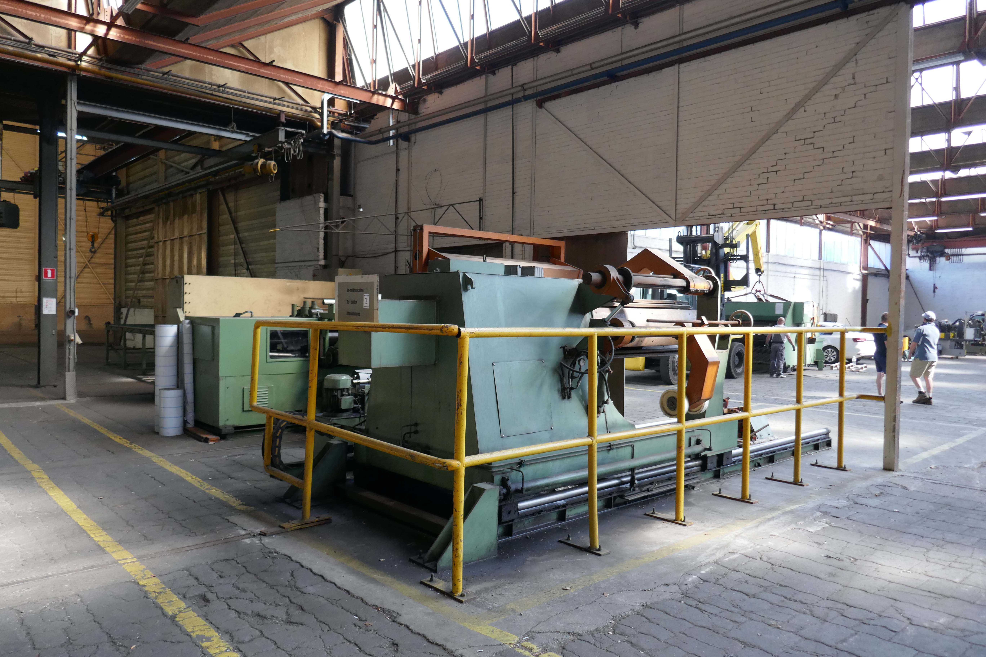

- Make : ARKU Germany
- Typ : VRM 200 / 7 / 2000
- Serial No : WO 1576
- Age : 1989 in Work 1990

- ARKU Precision straightener VRM 200/7
- Working with : 2.050
- Number off rolls : 7
- Diameter rolls Ø : 220
- Feeding rolls : 2
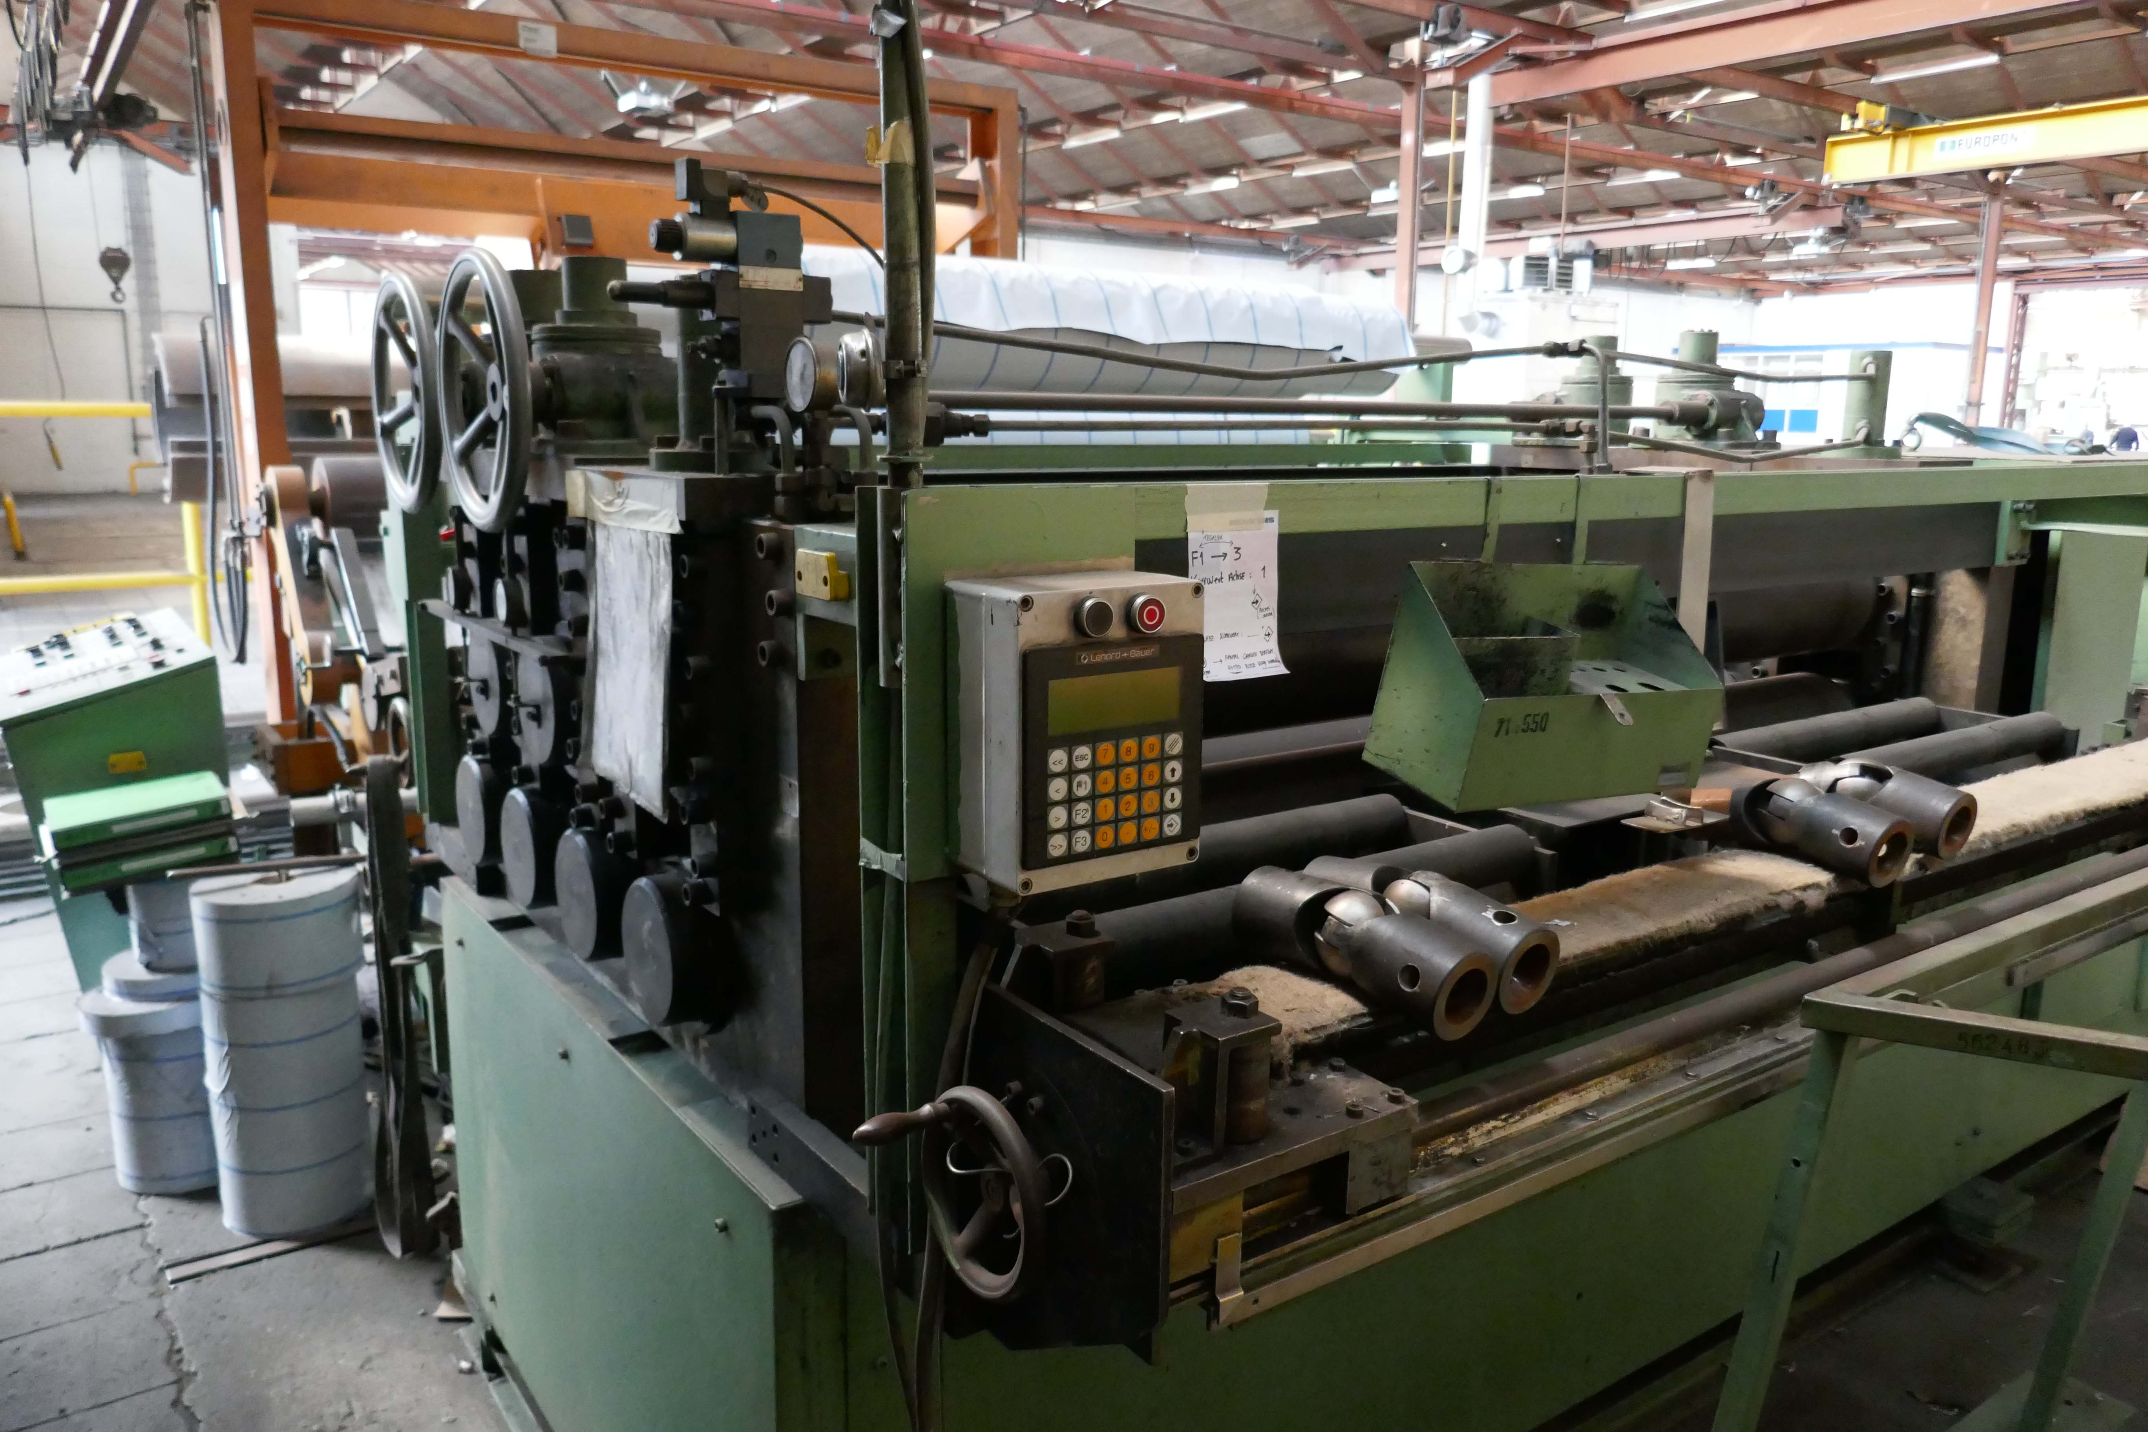
- Diameter feed roll : 200
- Feeding accuracy : 0,2 mm each Mtr
- Working speed : 10 M/Min

- Drive is with measure & counting device
- Central adjustable cardan driven
- Upper 3 roll un depending electric adjustable
- Upper roll is hydraulic liftable and adjustable

- ARKU Decoiler AH 12000 / 200 / MSG-4Q
- Max. thickness material : 6,3 mm
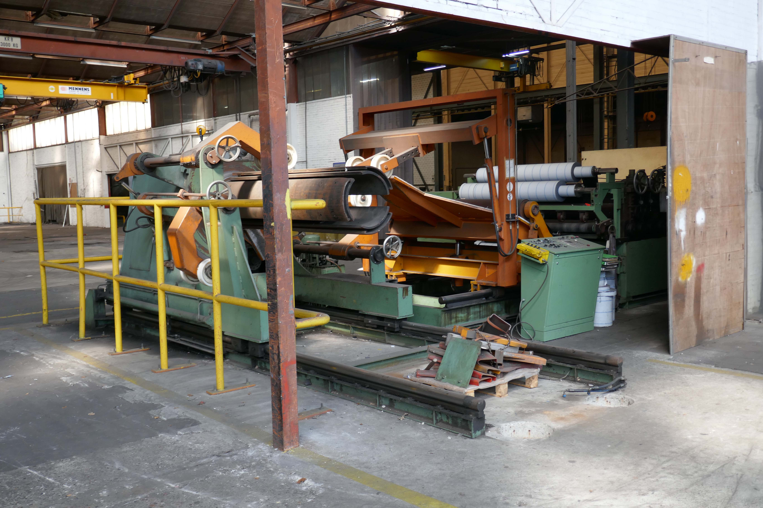
- Max. coil weight : 12000 Kg
- Coil width : 2000
- Feed width : 570 – 630
- Coiling speed : 0 – 10 M/Min
- Adjustment lower bed : 2400

Please Note: The above information has been obtained to the best of our ability and belief from, and from the manufacturers where possible. It is given in good faith, but its accuracy can not be guaranteed. Accordingly, it will not form a representation or constitute contractual terms. We advise you to check any vital details!

